**Step1:**

Please make sure you have Docker installed instance. If not follow below steps to install Docker.

Ø apt-get update

Ø apt install docker.io

Ø apt-get update

Ø java –version

Ø apt install default-jre

Ø apt install default-jdk

Ø apt-get update

**Step2:**

To deploy a website, we have to create a directory so that we can create all required file in this dir.

Ø **mkdir test-website**

Ø **cd test-website**

Ø **vi index.html**

*<html><h1> Hi ,This website is running on Docker container!!<h1>:<html>*

We can deploy with apache ,first need to create a **Dockerfile.**

root@ip-172-31-34-63:~/test-website# **cat Dockerfile**

*FROM httpd:2.4*

*COPY . /usr/local/apache2/htdocs/*

**Step3:**

**Now need to build image.**

root@ip-172-31-34-63:~/test-website# docker build -t test-website .

**Sending build context to Docker daemon 3.072kB**

**Step 1/2 : FROM httpd:2.4**

**2.4: Pulling from library/httpd**

**000eee12ec04: Pull complete**

**32b8712d1f38: Pull complete**

**f1ca037d6393: Pull complete**

**c4bd3401259f: Pull complete**

**0213122c8c28: Pull complete**

**Digest: sha256:a45d041cc64876eade5209784c472f373886950925e86a233f73c3f577c9d207**

**Status: Downloaded newer image for httpd:2.4**

**---> d4a061d58465**

**Step 2/2 : COPY . /usr/local/apache2/htdocs/**

**---> 92f86e0d592a**

**Successfully built 92f86e0d592a**

**Successfully tagged test-website:latest**

Ø root@ip-172-31-34-63:~/test-website# **docker images**| It will show images have been created and in running state.

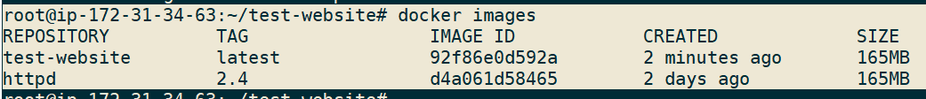

Ø **docker run -dit --name docker-test1-website -p 8080:80 test-website| To running container in detach /interactive mode with mapped port and in sudo terminal.**

**Output:**



981e2ed8985a8056b95892b5c7f3f54b54d9ec6f3c0defddd5f7d98800c18404

**Step4:**

Ø **Now take Public IP of your instance and run with port number as we defined.**